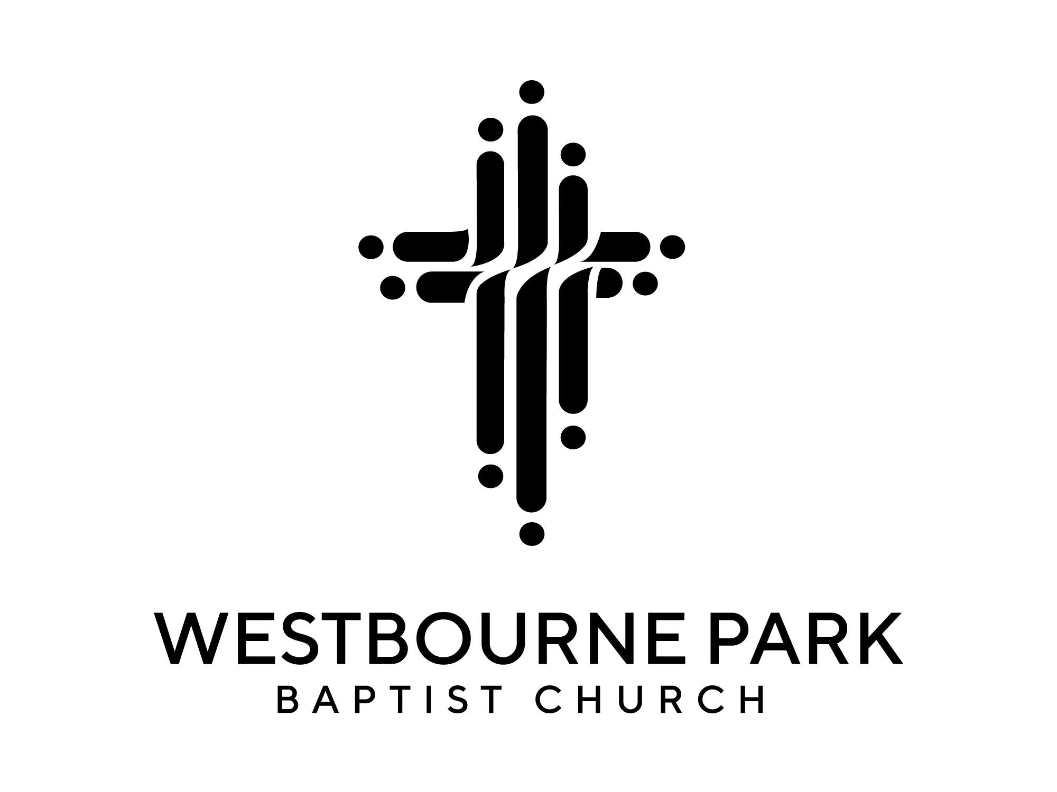
Church Member’s Meeting Agenda
Sunday 10th January 2021 13:00 on zoom

Opening Words and Prayer | Ken Asiedu
Minutes of last meeting

How are we? | Abena Boateng
Discussion | Small groups
Feedback and questions | Core Leaders
Pastoral support for Hil | Elizabeth Welch
Church Structure and getting involved | Elizabeth Welch
Discussion | Small groups
Feedback and questions | Core Leaders
Financial update | Geoff Biggs
Prayer (for financial situation) | Small groups
Closing Prayer | Ken Asiedu

