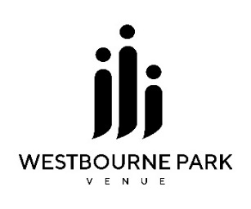

BOOKING FORM

1. Name of contact person:
2. Organisation:
3. Contact E-mail: Contact phone:
4. Contact Address:
5. Purpose of Hire:
6. Start Date:
7. Finish Date:
8. Start Time:
9. Finish Time:
10. Number of Attendees:
11. Number of Tables:
12. Number of Chairs:

Please indicate your preferred room layout:

Theatre

U-Shape

Classroom

Boardroom

Banquet

Cabaret

[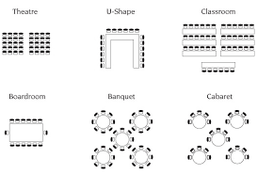](https://www.google.co.uk/url?sa=i&rct=j&q=&esrc=s&source=images&cd=&cad=rja&uact=8&ved=2ahUKEwilkOirnYXmAhUMmRQKHRkRDREQjRx6BAgBEAQ&url=%2Furl%3Fsa%3Di%26rct%3Dj%26q%3D%26esrc%3Ds%26source%3Dimages%26cd%3D%26ved%3D%26url%3Dhttp%253A%252F%252Fwww.airportmotelmelbourne.com.au%252Fconferences-events%252Fsetup-styles%252F%26psig%3DAOvVaw3TuwUJoOsesvBBdZWo7R3O%26ust%3D1574766348404763&psig=AOvVaw3TuwUJoOsesvBBdZWo7R3O&ust=1574766348404763)

1. Will food be required? (please note this is available through Patience Catering, and a quote can be requested on your behalf. Please indicate your preferences)

Number of people:

Number of Vegetarians:

Number of Vegans:

Allergies (please specify):

Morning pastries Sandwich lunch Soup and rolls

Hot or cold buffet Cakes or biscuits Fruit Platter

1. Which rooms would you like to book? (Please refer to website for details of room capacity)

Sanctuary 250 people (seated)

Clifford Hall 150 people (seated)

Kitchen 006 people

Family Room 010 people (seated)

Acorn Room 020 people (seated)

Oak Room 030 people (seated)

Acorn + Oak 050 people (seated)

Welcome Area 025 people (seated)

1. Requested Equipment:

Projector

TV

PA + Microphone

White Board

Flip Chart

Wi-Fi

1. Customer’s Comments:
2. WP Venue use only:

|  |  |
| --- | --- |
| Name of person who received booking |  |
| Date of booking: |  |
| Timings of booking: |  |
| Type of organisation: | External / Christian Organisation / Community / Not for Profit / Partner / WPBC |
| Does an offer / reduction apply? | Yes / No |
| Tea/coffee requirements (inclusive in price) |  |
| Request quote for Catering requirements: | Date: |
| Amount of deposit paid: | £ |
| Date deposit received |  |
| Route of deposit payment: | Cash / Card / BACS / Invoice (authorisation code if card payment by phone: )  Please attach card payment receipt. |
| Amount of full payment due | £ |
| Date full payment due |  |
| Route of payment: | Cash / Card / BACS / Invoice (authorisation code if card payment by phone: )  Please attach card payment receipt. |
| Booking number |  |
| Enter booking on Skedda | Date entered: |
| Complete Notes section with details of booking above |  |
| Email a copy of this sheet to Patricia Chering, Facilities Team and Caterer | Date emailed: |
| Financial Actions |  |
| Generate invoice on Quickbooks | Invoice number: |
| Email or post invoice to contact person | Date: |
| Monitor deposit payment | Date paid: |
| Monitor income against invoice | Date full payment received: |
| Generate receipt |  |
| Mark as ‘paid’ on Skedda |  |